Lab 1
Introduction to Vivado Design Suite
and Basic Gate-Level Modeling in
SystemVerilog

Hanan Alosaimi

repo link:
https://github.com/hanan0101/01Design_repo.git

TASK 1 : 4-input andgate Simulation

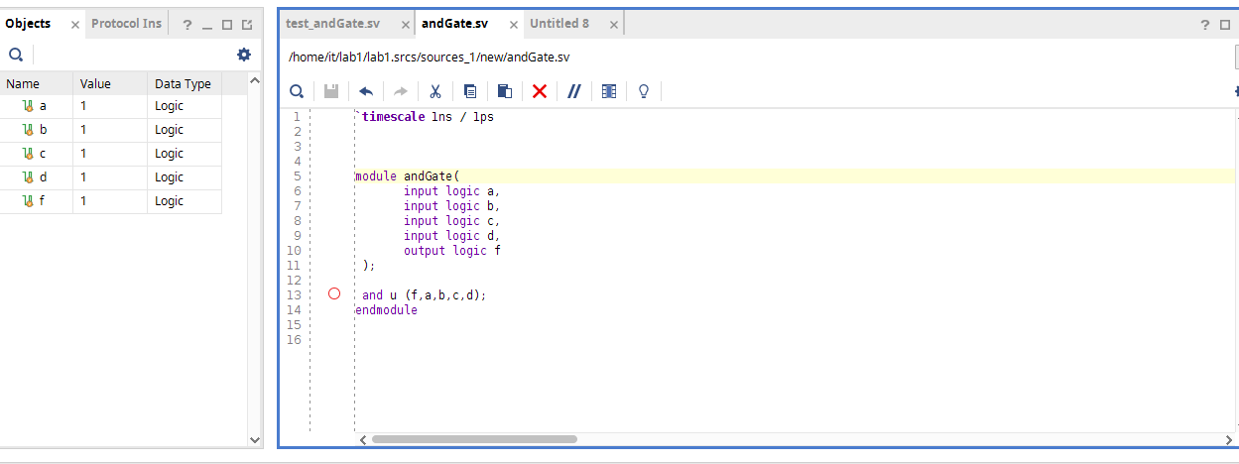

testbench:
`timescale 1ns / 1ps

module test_andGate;
logic a, b, c,d;
logic f;

andGate dut (
.a(a),
.b(b),
.c(c),
.d(d),
.f(f)
);
initial begin

// Display header
$display("Time\t a b c d f");

a = 0; b = 0; c = 0; d = 0; #10;
// Display the value of a, b, c, and d along with time
$display("%0t\t %b\t %b\t %b\t %b\t %b", $time, a, b, c, d,f);

a = 0; b = 0; c = 0; d = 1; #10;
$display("%0t\t %b\t %b\t %b\t %b\t %b", $time, a, b, c, d,f);

a = 0; b = 0; c = 1; d = 0; #10;
$display("%0t\t %b\t %b\t %b\t %b\t %b", $time, a, b, c, d,f);

a = 0; b = 0; c = 1; d = 1; #10;
$display("%0t\t %b\t %b\t %b\t %b\t %b", $time, a, b, c, d,f);

a = 0; b = 1; c = 0; d = 0; #10;
$display("%0t\t %b\t %b\t %b\t %b\t %b", $time, a, b, c, d,f);

a = 0; b = 1; c = 0; d = 1; #10;
$display("%0t\t %b\t %b\t %b\t %b\t %b", $time, a, b, c, d,f);

a = 0; b = 1; c = 1; d = 0; #10;
$display("%0t\t %b\t %b\t %b\t %b\t %b", $time, a, b, c, d,f);

a = 0; b = 1; c = 1; d = 1; #10;
$display("%0t\t %b\t %b\t %b\t %b\t %b", $time, a, b, c, d,f);

a = 1; b = 0; c = 0; d = 0; #10;
$display("%0t\t %b\t %b\t %b\t %b\t %b", $time, a, b, c, d,f);

a = 1; b = 0; c = 0; d = 1; #10;
$display("%0t\t %b\t %b\t %b\t %b\t %b", $time, a, b, c, d,f);

a = 1; b = 0; c = 1; d = 0; #10;
$display("%0t\t %b\t %b\t %b\t %b\t %b", $time, a, b, c, d,f);

a = 1; b = 0; c = 1; d = 1; #10;
$display("%0t\t %b\t %b\t %b\t %b\t %b", $time, a, b, c, d,f);

a = 1; b = 1; c = 0; d = 0; #10;
$display("%0t\t %b\t %b\t %b\t %b\t %b", $time, a, b, c, d,f);

a = 1; b = 1; c = 0; d = 1; #10;
$display("%0t\t %b\t %b\t %b\t %b\t %b", $time, a, b, c, d,f);

a = 1; b = 1; c = 1; d = 0; #10;
$display("%0t\t %b\t %b\t %b\t %b\t %b", $time, a, b, c, d,f);

a = 1; b = 1; c = 1; d = 1; #10;
$display("%0t\t %b\t %b\t %b\t %b\t %b", $time, a, b, c, d,f);

// End simulation

$finish;

end

endmodule

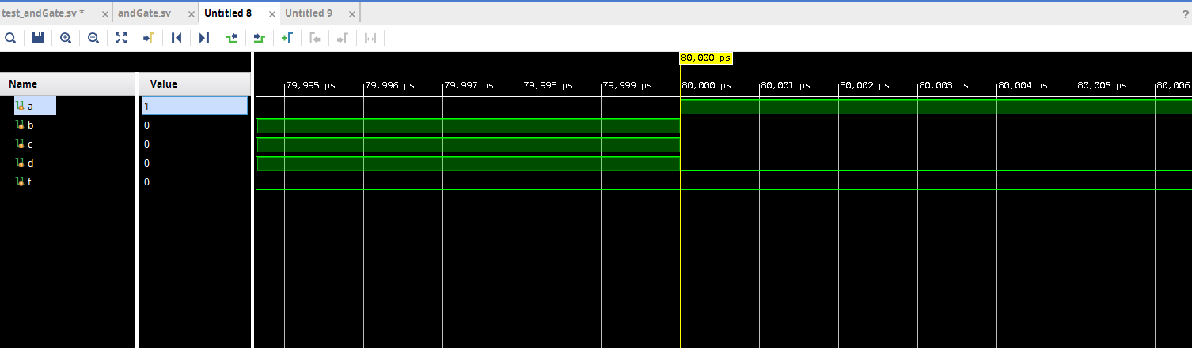

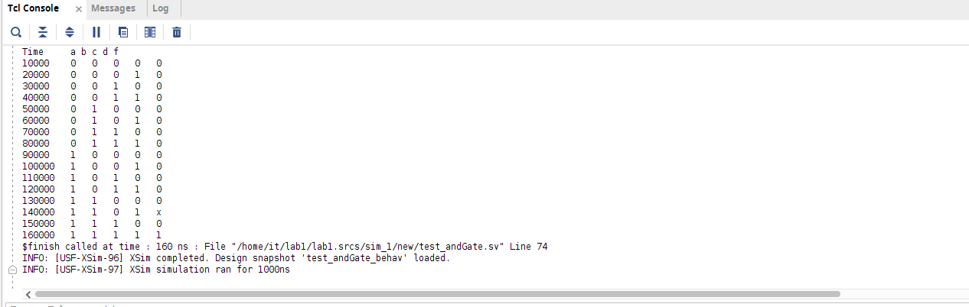

TASK 2 : Half Adder

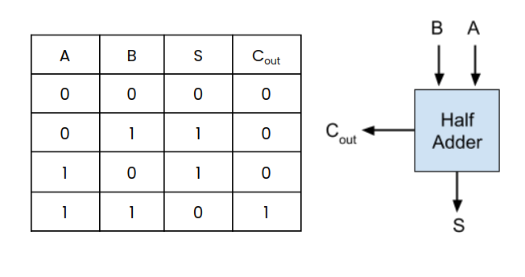

source code:
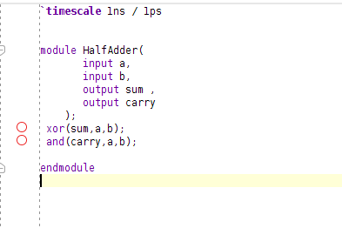

`timescale 1ns / 1ps

module test_HD;
logic a, b, sum ,carry;

//inctsance
HalfAdder hd(a,b,sum,carry);

initial begin

// Display header
$display("Time\t a b sum, carry");

a = 0; b = 0; ; #10;
// Display the value of a, b, c, and d along with time
$display("%0t\t %b\t %b\t %b %b", $time, a, b, sum ,carry);
#3
a = 1; b = 0; ; #10;

$display("%0t\t %b\t %b\t %b %b", $time, a, b, sum ,carry);
#5
a = 0; b = 1; ; #10;

$display("%0t\t %b\t %b\t %b %b", $time, a, b, sum ,carry);
a = 1; b = 1; ; #10;
#7
$display("%0t\t %b\t %b\t %b %b", $time, a, b, sum ,carry);

$finish;
end
endmodule

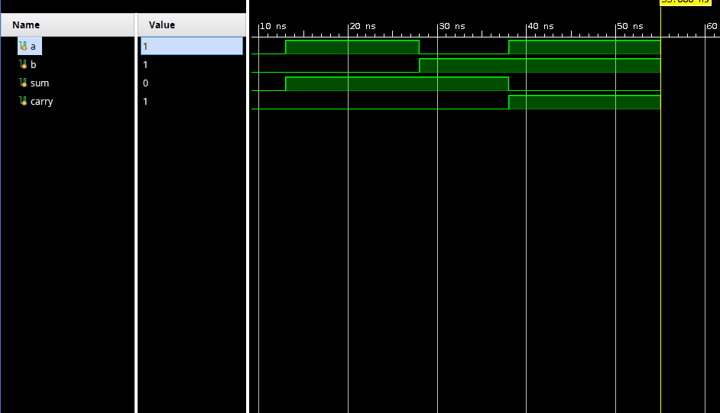

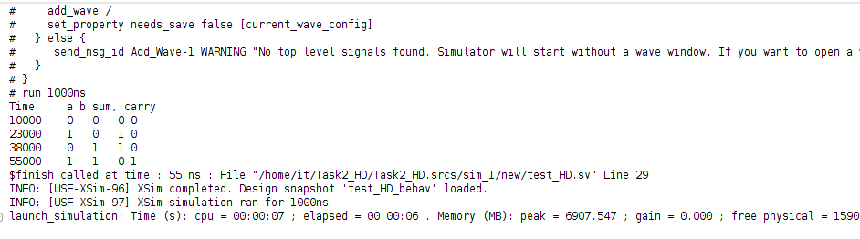

TASK3
TASK 3 : Full Adder
Design and simulate a Full Adder using half adders from TASK 2

code :

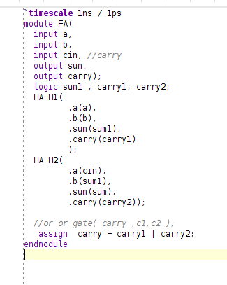

`timescale 1ns / 1ps

module test_FA;
logic a,b,cin, sum ,carry;

// inctace
HA ha (
.a(a),
.b(b),
.sum(sum),
.carry(carry)

);

FA fa(
.a(a),
.b(b),
.cin(cin),
.sum(sum),
.carry(carry)
);

initial begin

// Display header
$display("Time\t a b cin sum, carry");

a = 0; b = 0; cin=0; #10;
// Display the value of a, b, c, and d along with time
$display("%0t\t %b\t %b\t %b\t %b %b", $time, a, b, sum ,carry);
#3
a = 1; b = 0; cin=0; #10;
// Display the value of a, b, c, and d along with time
$display("%0t\t %b\t %b\t %b\t %b %b", $time, a, b, sum ,carry);
#3
a = 0; b = 1; cin=0; #10;
// Display the value of a, b, c, and d along with time
$display("%0t\t %b\t %b\t %b\t %b %b", $time, a, b, sum ,carry);
#3
a = 0; b = 0; cin=1; #10;
// Display the value of a, b, c, and d along with time
$display("%0t\t %b\t %b\t %b\t %b %b", $time, a, b, sum ,carry);
#3
a = 1; b = 1; cin=0; #10;
// Display the value of a, b, c, and d along with time
$display("%0t\t %b\t %b\t %b\t %b %b", $time, a, b, sum ,carry);
#3
a = 1; b = 0; cin=1; #10;
// Display the value of a, b, c, and d along with time
$display("%0t\t %b\t %b\t %b\t %b %b", $time, a, b, sum ,carry);
#3
a = 0; b = 1; cin=1; #10;
// Display the value of a, b, c, and d along with time
$display("%0t\t %b\t %b\t %b\t %b %b", $time, a, b, sum ,carry);
#3
a = 1; b = 1; cin=0; #10;
// Display the value of a, b, c, and d along with time
$display("%0t\t %b\t %b\t %b\t %b %b", $time, a, b, sum ,carry);
#3
a = 1; b = 1; cin=1; #10;
// Display the value of a, b, c, and d along with time
$display("%0t\t %b\t %b\t %b\t %b %b", $time, a, b, sum ,carry);

$finish;
end
endmodule

the output:

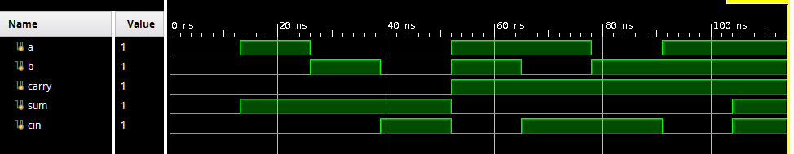
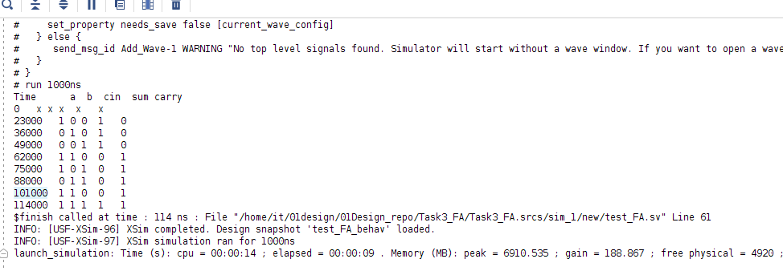

Task5:
